LAB TASK #06

Name: Naqeebullah
Roll No.: 25P-0660
Section: BCS-1B
Lab Instructor: Sir Behram Shah

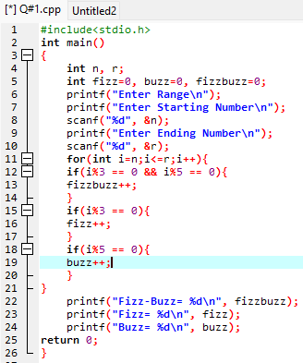
Question #01:
#include<stdio.h>
int main()
{
int n, r;
int fizz=0, buzz=0, fizzbuzz=0;
printf("Enter Range\n");
printf("Enter Starting Number\n");
scanf("%d", &n);
printf("Enter Ending Number\n");
scanf("%d", &r);
for(int i=n;i<=r;i++){
if(i%3 == 0 && i%5 == 0){
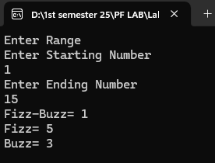
fizzbuzz++;
}
if(i%3 == 0){
fizz++;
}
if(i%5 == 0){
buzz++;
}
}
printf("Fizz-Buzz= %d\n", fizzbuzz);
printf("Fizz= %d\n", fizz);
printf("Buzz= %d\n", buzz);
return 0;
}
Question #02:
#include<stdio.h>
int main()
{
int a=0, b=1, next, sum=0;
printf("Fabonacci series upto 10000\n");
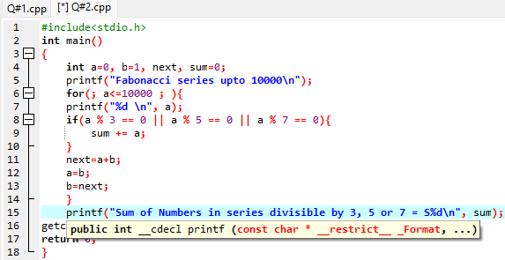
for(; a<=10000 ; ){
printf("%d \n", a);
if(a % 3 == 0 || a % 5 == 0 || a % 7 == 0){
sum += a;
}
next=a+b;
a=b;
b=next;
}
printf("Sum of Numbers in series divisible by 3, 5 or 7 = %d\n", sum);
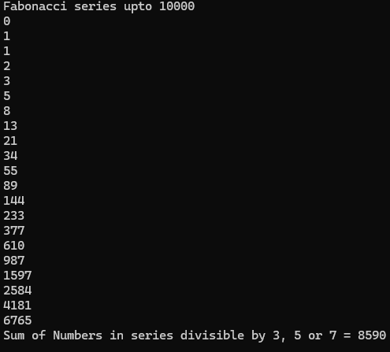
getchar();
return 0;
}

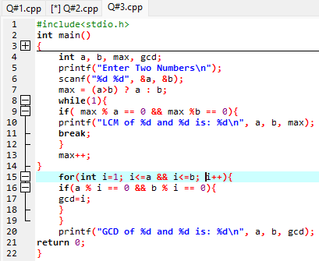
Question #03:
#include<stdio.h>
int main()
{
int a, b, max, gcd;
printf("Enter Two Numbers\n");
scanf("%d %d", &a, &b);
max = (a>b) ? a : b;
while(1){
if( max % a == 0 && max %b == 0){
printf("LCM of %d and %d is: %d\n", a, b, max);
break;
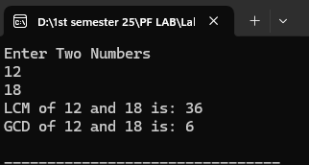
}
max++;
}
for(int i=1; i<=a && i<=b; i++){
if(a % i == 0 && b % i == 0){
gcd=i;
}
}
printf("GCD of %d and %d is: %d\n", a, b, gcd);
return 0;
}

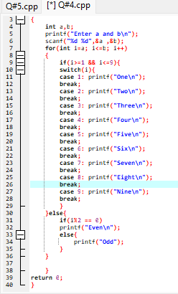
Question #04:
#include<stdio.h>
int main()
{
int a,b;
printf("Enter a and b\n");
scanf("%d %d",&a ,&b);
for(int i=a; i<=b; i++)
{
if(i>=1 && i<=9){
switch(i){
case 1: printf("One\n");
break;
case 2: printf("Two\n");
break;
case 3: printf("Three\n");
break;
case 4: printf("Four\n");
break;
case 5: printf("Five\n");
break;
case 6: printf("Six\n");
break;
case 7: printf("Seven\n");
break;
case 8: printf("Eight\n");
break;
case 9: printf("Nine\n");
break;
}
}else{
if(i%2 == 0)
printf("Even\n");
else{
printf("Odd");
}
}

}
return 0;
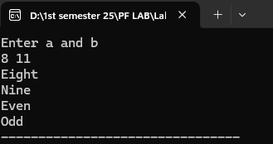
}

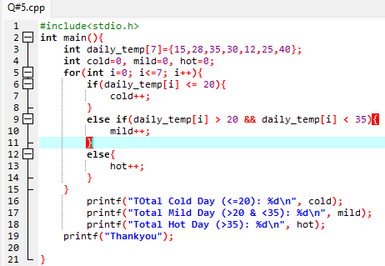
Question #05:
#include<stdio.h>
int main(){
int daily_temp[7]={15,28,35,30,12,25,40};
int cold=0, mild=0, hot=0;
for(int i=0; i<=7; i++){
if(daily_temp[i] <= 20){
cold++;
}
else if(daily_temp[i] > 20 && daily_temp[i] < 35){
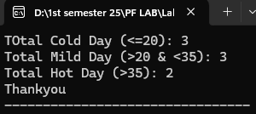
mild++;
}
else{
hot++;
}
}
printf("TOtal Cold Day (<=20): %d\n", cold);
printf("Total Mild Day (>20 & <35): %d\n", mild);
printf("Total Hot Day (>35): %d\n", hot);
printf("Thankyou");
return 0;
}

Question #06:
#include<stdio.h>
int main()
{
for(int i=0; i<=6; i++){
if(i%2 != 0)
printf("\t %d\t %d\t \t \n", i,i);
else
printf("%d\t %d\t %d\t %d\n", i, i, i, i);
}
return 0;
}
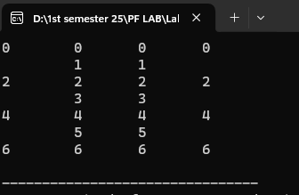
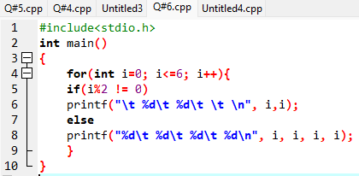

Question #07:
#include<stdio.h>
int main()
{
int num[7];
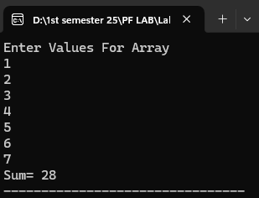
int sum=0;
printf("Enter Values For Array\n");
for(int i=0; i<7; i++)
{
scanf("%d", &num[i]);
sum+=num[i];
}

printf("Sum= %d", sum);
return 0;
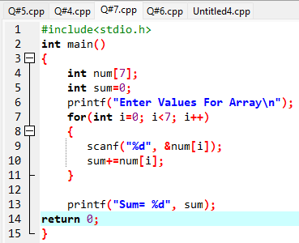
}
Question #08:
#include<stdio.h>
int main()
{
int n;
printf("Enter How many Number do you want To store in Array\n");
scanf("%d", &n);
printf("Enter Numbers\n");
int num[n];
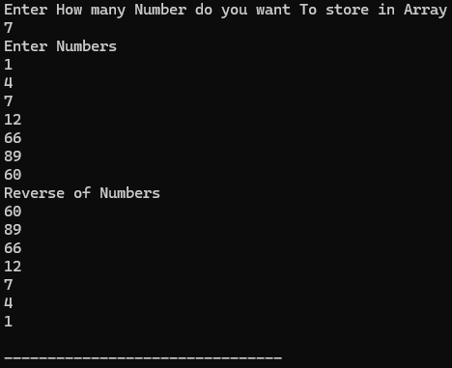
for(int i=0; i<n; i++)
{
scanf("%d", &num[i]);
}
printf("Reverse of Numbers\n");
for(int i=n-1; i>=0; i--)
{
printf("%d\n", num[i]);
}
return 0;
}
